 | Abstract title (Calibri, size 14, bold) | Put here your  Institute logo
N. Surname1, N. Surname2, N. Surname3
Affiliation – Institute Name, Address
e-mail: e-mail to corresponding author
Keywords: keyword 1; keyword 2; keyword 3; etc.
It is the cell on this and the next pages where you can put your abstract:
- It can have a more graphical or more written form (the organizers strongly encourage the authors of abstracts to present their research problems and the obtained results in graphical forms as much as possible);
- It can have one or two pages – this template is designed for 2-pages abstracts;
- It has to be written in English;
- All the graphics within the abstract should have a proper quality, at least 300 DPI;
- All the texts included within the graphics should be legible and written using Calibri font, size 10;
- All the graphics and texts included in the abstract should be original graphics or texts prepared by the authors of the abstract. It is not allowed to include graphics or fragments of texts coming from other sources;
- All the cells (rows and columns) of this table should have the same dimensions as they have in this original template;
- Equations, figures, and tables don’t need to be numbered;
- Any text within this box should be written using Calibri font, size 10.

When you submit the abstract to the Polish Biomedical Engineering Conference (hold in Poznań, 19-20.11.2026), you confirm that all the authors have been informed. Furthermore, they all agree to publish the abstract after its approval by the organizers.

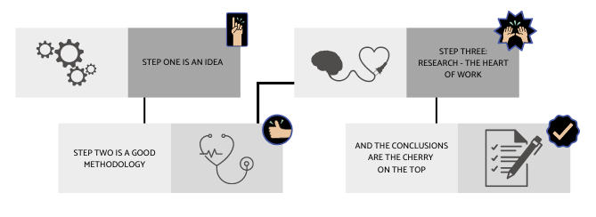
Fig. 1. Sample graphics
Acknowledgements (optional)
If applicable, you can acknowledge any kind of help in your research here (Calibri, size 10).
If not applicable, you can merge this row with the previous or next one.
References:
[1] N. Surname, Book Title, Publisher , Berlin, 2010.
[2] N. Surname of the first author et al., Article Title, Journal Title (abbreviated), Vol. Number, Year, pp. Pages Numbers.

